* Use of semantics is a good practice
* Only use class if tag is used multiple times, otherwise just use inline tags
* Finish HTML First then CSS
* For CSS, go for main selector tags first like paragraph and body (for header)
* 1em = 16px
* Use rem or em units for fonts for responsiveness
* Margin and padding work similar
  + Margin works outside element
  + Padding works inside element
* 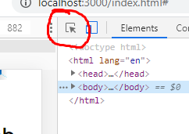Tip: To see padding or margin, click on the encircled icon and hover it on the webpage
* You can always switch-up   
  order of CSS
* Put display:block; if you’re going to  
  give an anchor text some width
* Block allows us to set a width and   
  height on
* When using z-index, input values  
  that are far from each other so  
  you can insert as many in-between.
* Text-align can be used for images
* max-width and min-width overrides width